**How to navigate to view the USB port disabled setup on both Jamf Pro and Jamf Protect**

**Step 1**:-

Login to the Jamf Pro console (<https://zumigo.jamfcloud.com> )and create the policy for Jamf Protect (that is default for now) as shown in SS below(1st Policy). That means we have integrated Jamf Pro with Jamf Connect. And patch will directly install in background in the next sync.

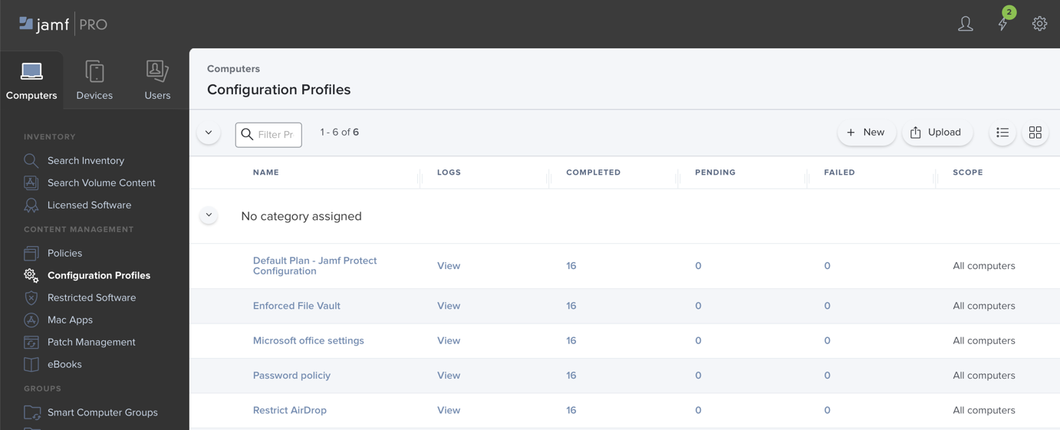

**Step 2**:-

Login to Jamf Protect Console (<https://zumigo.protect.jamfcloud.com> ) and click on the **device control** as shown in below SS. and click on **Create**

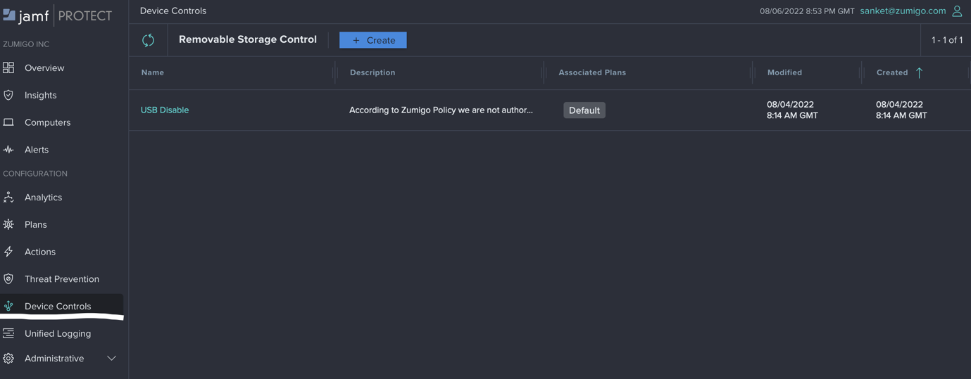

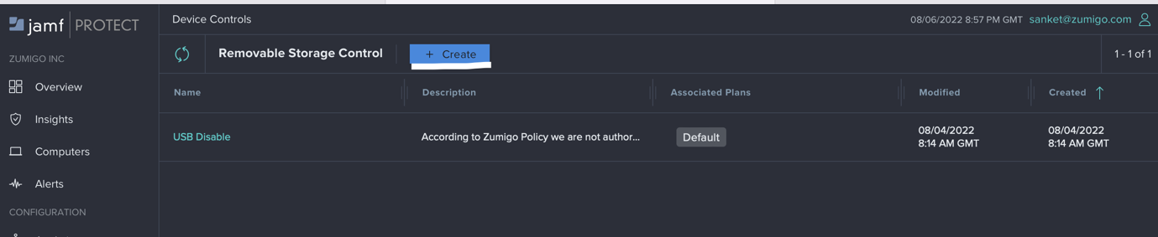

**Step 3**:-

Once you click on the Create you will get the (**Create Removable Storage Control Set)** fill the blank fields and click on save (Default Permission set as **Prevent**)

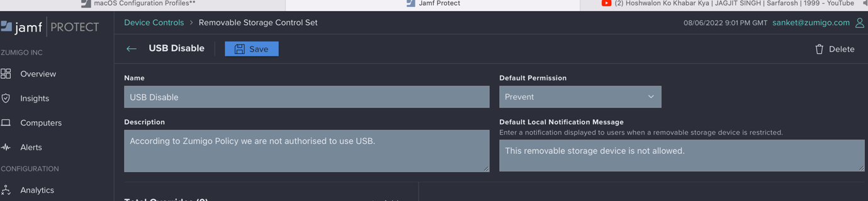

**Step 4**:-

Open the **Terminal** andcommand **sudo jamf recon** it will ask for the password then, Enter Laptop Password.

